ANGLES IN POLYGONS
Pearson Edexcel - Thursday 4 June 2020 - Paper 2 (Calculator) Foundation Tier

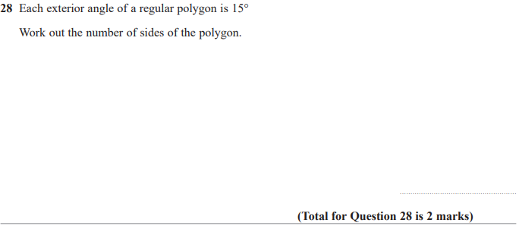

Pearson Edexcel - Monday 8 June 2020 - Paper 3 (Calculator) Foundation Tier

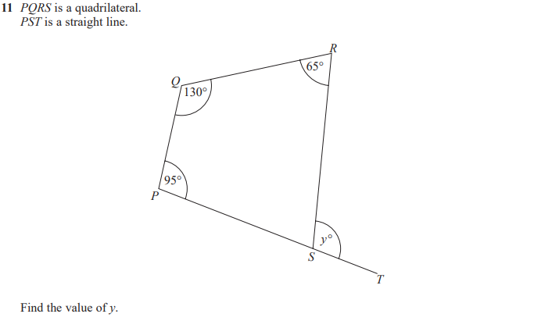

Pearson Edexcel - Tuesday 11 June 2019 - Paper 3 (Calculator) Foundation Tier

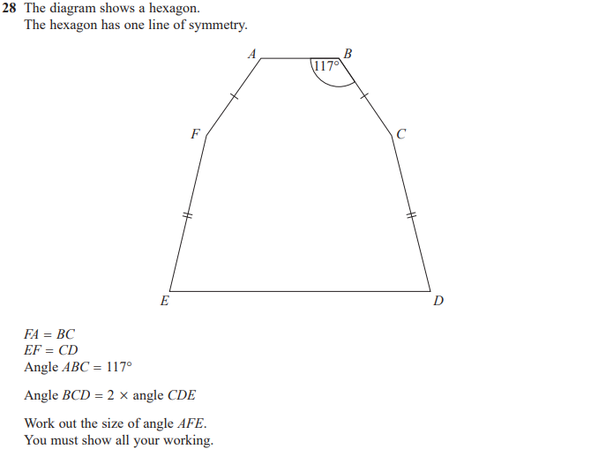

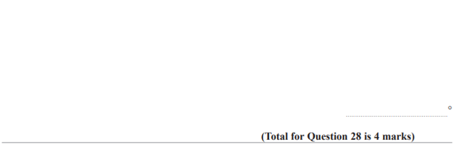
Pearson Edexcel - Tuesday 6 November 2018 - Paper 1 (Non-Calculator) Foundation Tier

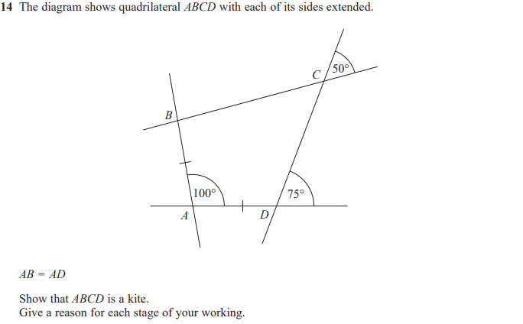

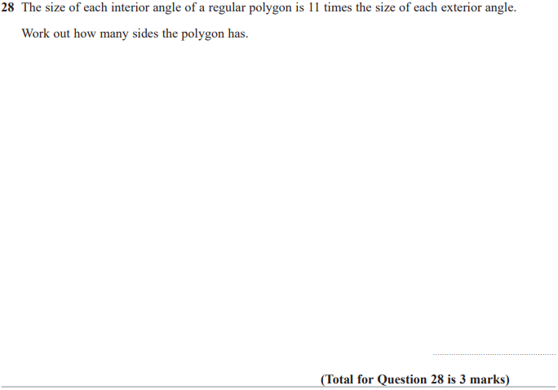

Pearson Edexcel - Tuesday 12 June 2018 - Paper 3 (Calculator) Foundation Tier

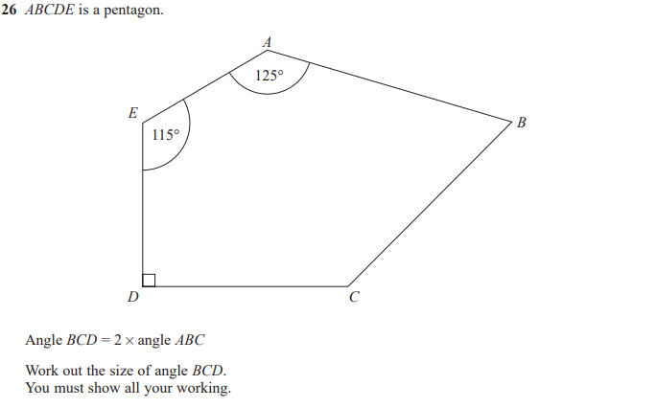
Pearson Edexcel - Wednesday 8 November 2017 - Paper 3 (Calculator) Foundation Tier

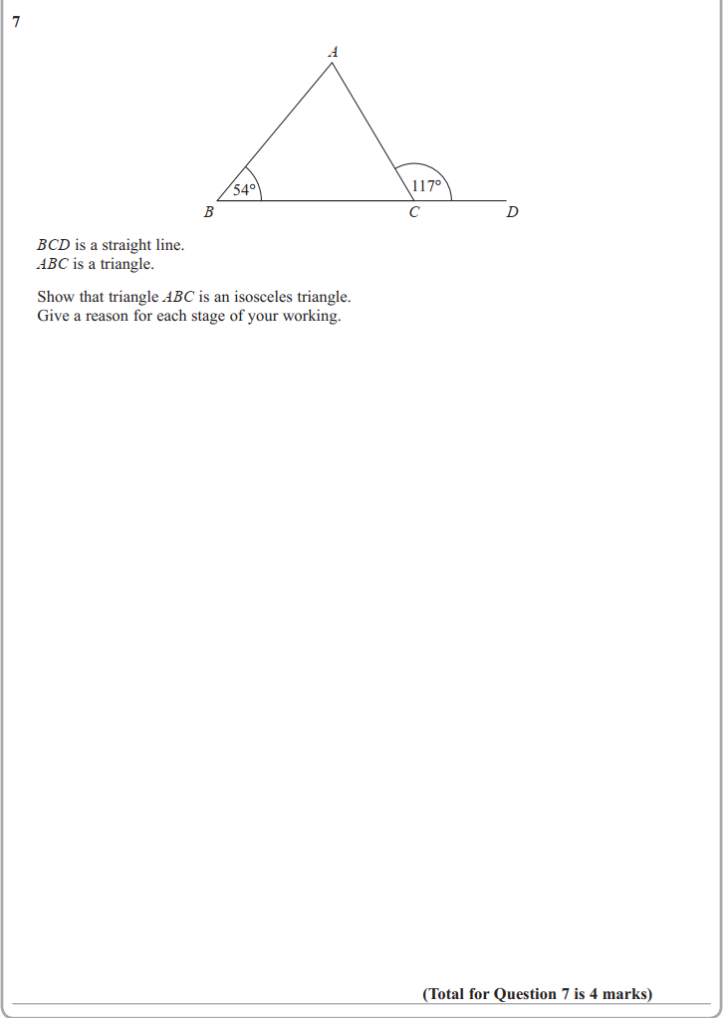

Pearson Edexcel – Specimen 2 - Paper 2 (Calculator) Foundation Tier

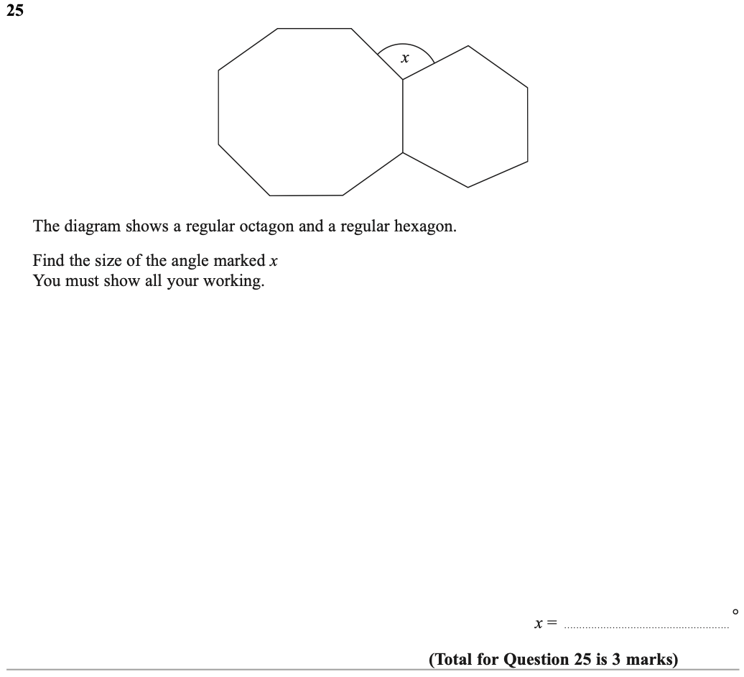

Pearson Edexcel – Specimen 2 - Paper 3 (Calculator) Foundation Tier

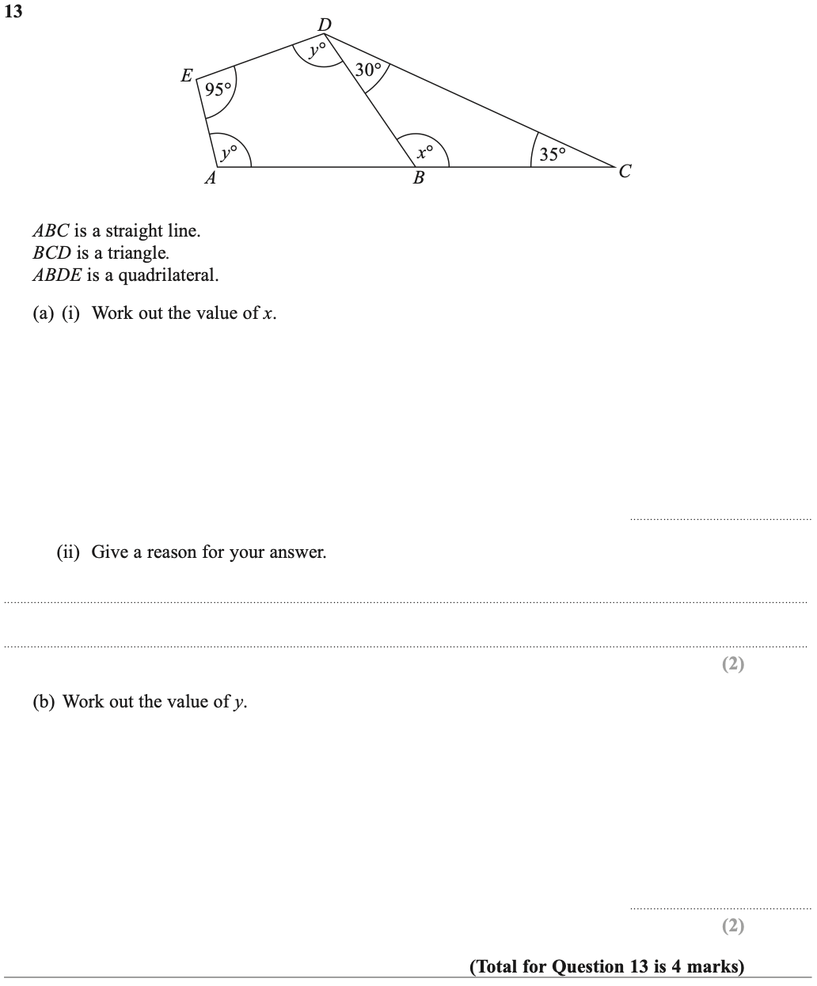

OCR Thursday 05 November 2020- Morning (Non-Calculator) Foundation Tier
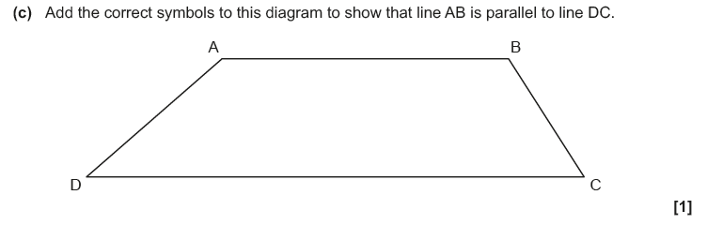
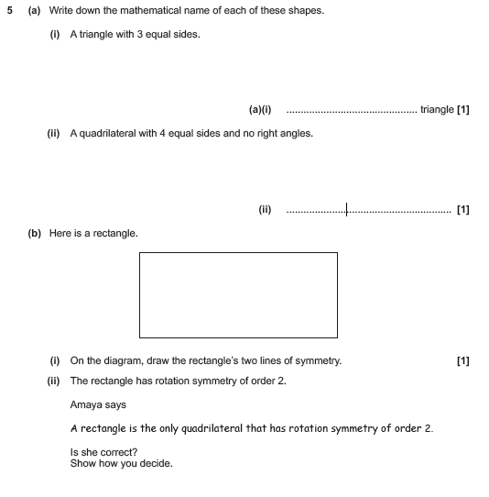

OCR November 09 November 2020- Morning (Calculator) Foundation Tier
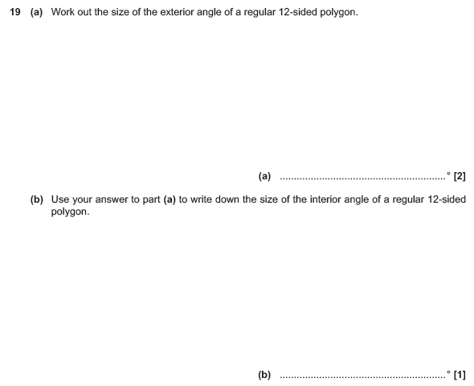

OCR Tuesday 5 November 2019 – Morning (Calculator) Foundation Tier
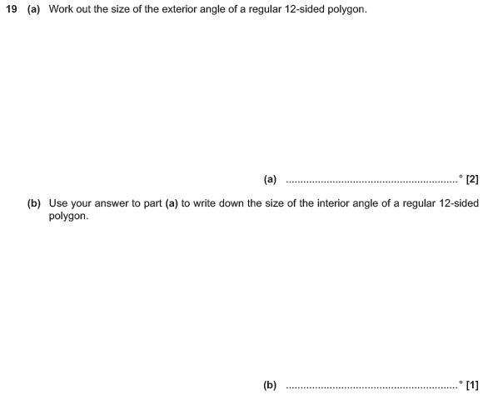

OCR Tuesday 6 November 2018 – Morning (Calculator) Foundation Tier
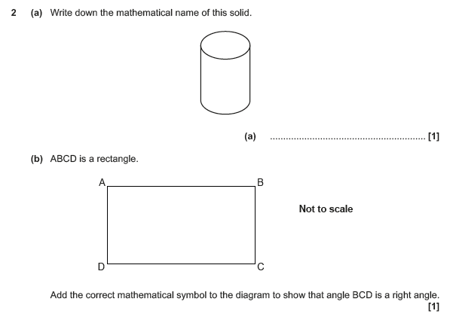

OCR Monday 12 November 2018 – Morning (Calculator) Foundation Tier

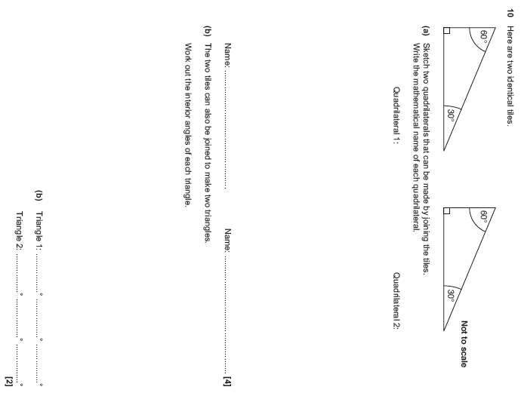

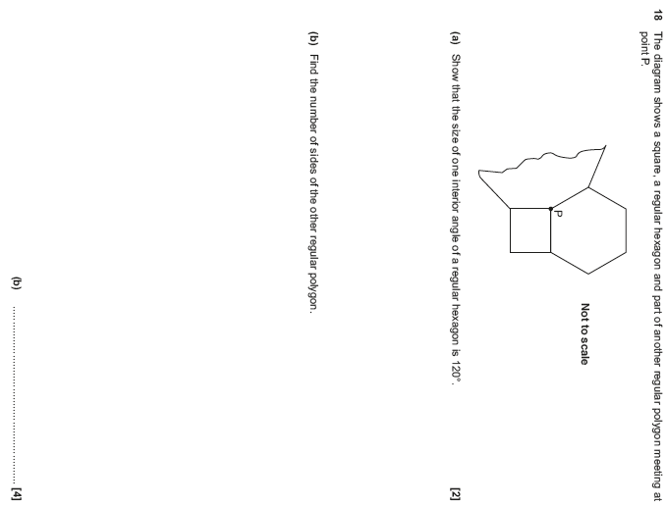

OCR Thursday 7 June 2018 – Morning (Non-Calculator) Foundation Tier

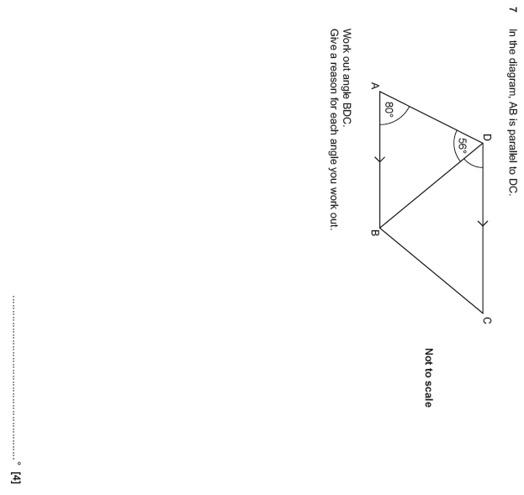

Pearson Edexcel – Sample Papers - Paper 1 (Non-Calculator) Foundation Tier

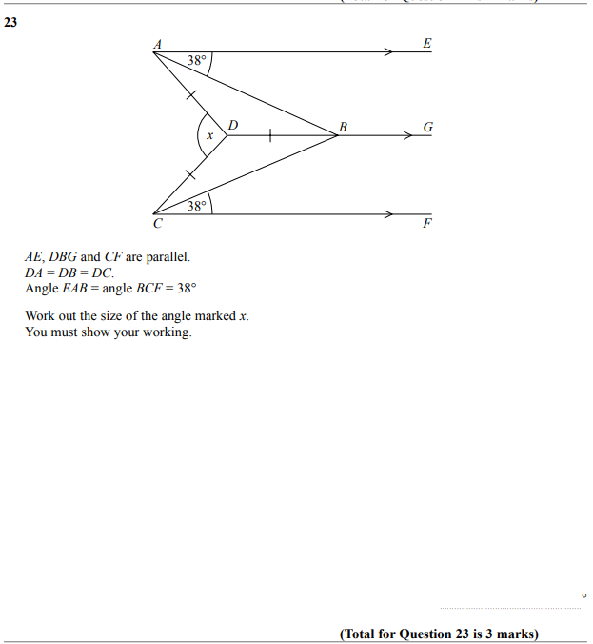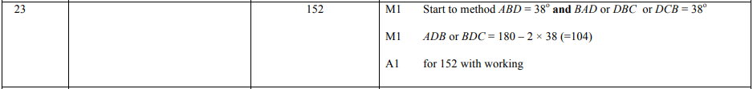

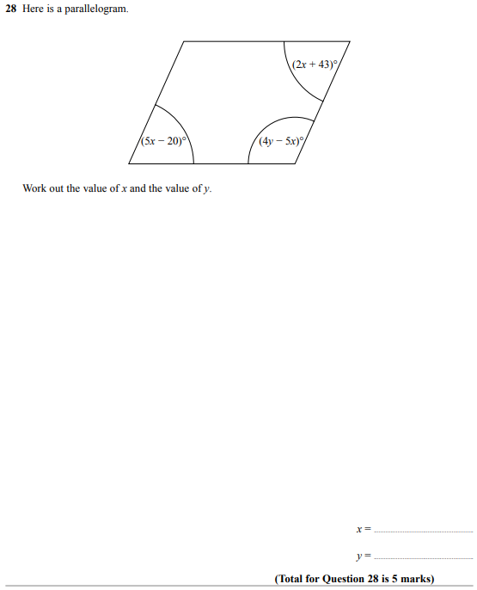

OCR Sample Question Paper 3 – Morning/Afternoon (Calculator) Foundation Tier

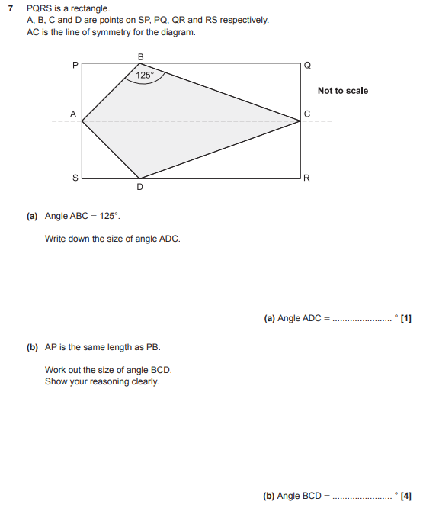

AQA Thursday 6 June 2019 – Morning (Calculator) Foundation Tier

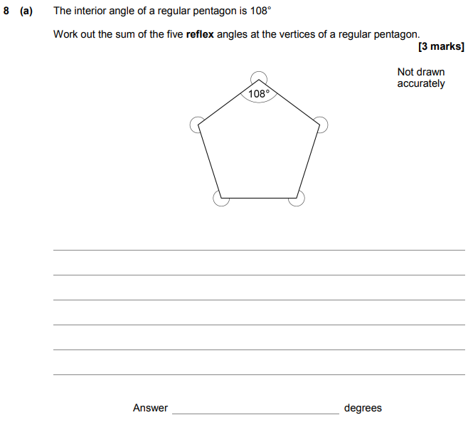
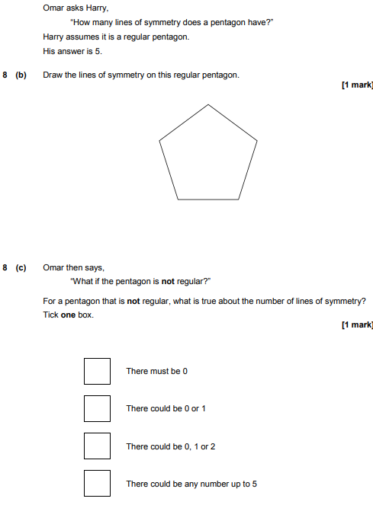

AQA Tuesday 6 November 2018 – Morning (Non-Calculator) Foundation Tier

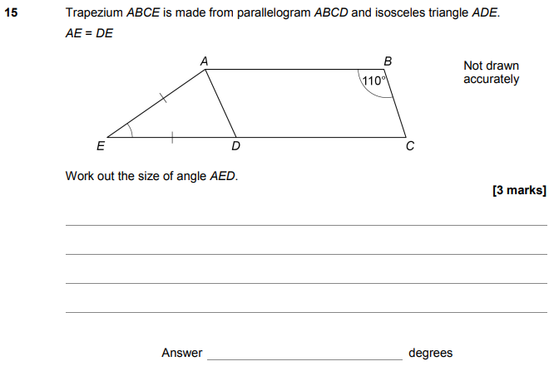

AQA Tuesday 6 November 2018 – Morning (Non-Calculator) Foundation Tier

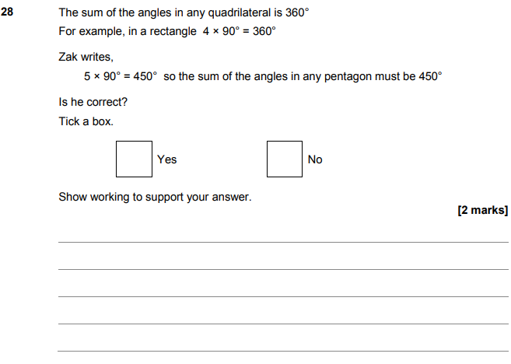

AQA Thursday 2 November 2017 – Morning (Non-Calculator) Foundation Tier

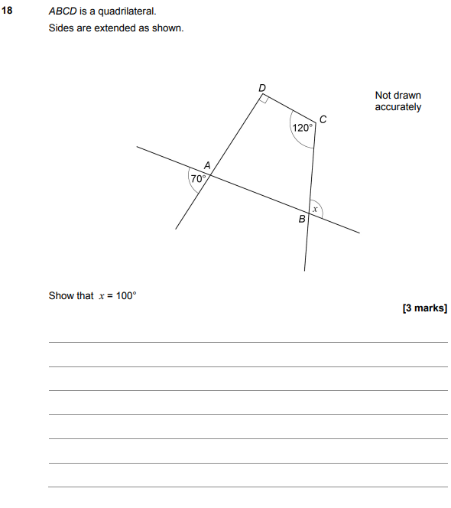

AQA Wednesday 8 November 2017 – Morning (Calculator) Foundation Tier

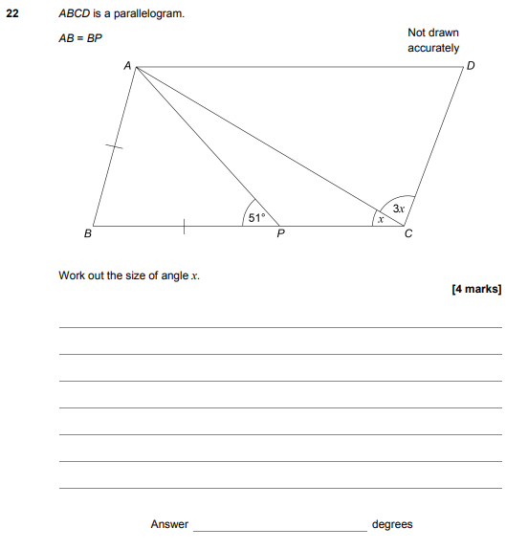

AQA Thursday 25 May 2017– Morning (Non-Calculator) Foundation Tier

